|  |  |  |  |
| --- | --- | --- | --- |
| LAB 5 (week 4 chapter 05)HTML Tables and Forms  |  | | --- | | What You Will Learn   * How to create HTML tables * How to style tables * How to create HTML forms |  |  | | --- | | Approximate Time  The exercises in this lab should take approximately 60 minutes to complete. | |  | |

## Creating Tables

|  |
| --- |
| Preparing Directories |
| 1 | If you haven’t done so already, create a folder in your personal drive for all the labs for this book. |
| 2 | From the main labs folder (either downloaded from the textbook’s web site using the code provided with the textbook or in a common location provided by your instructor), copy the folder titled lab05 to your course folder created in step one. |

The <table> element in HTML represents information that exists in a two-dimensional grid. Tables can be used to display calendars, financial data, pricing tables, and many other types of data. Just like a real-world table, an HTML table can contain any type of data: not just numbers, but text, images, forms, even other tables.

|  |
| --- |
| Exercise 5. — Create a Basic Table |
| 1 | Open, examine, and test lab05-exercise01.html in browser. |
| 2 | Add the following markup to the document.  <body>  <table>  <tr>  <td>The Death of Marat</td>  <td>Jacques-Louis David</td>  <td>1793</td>  <td>162cm</td>  <td>128cm</td>  </tr>  <tr>  <td>Burial at Ornans</td>  <td>Gustave Courbet</td>  <td>1849</td>  <td>314cm</td>  <td>663cm</td>  </tr>  </table>  </body>  The indenting shown here is purely for clarity purposes (that is, it is there to help you see the structure of the table more clearly). It is up to you whether you want to space the table markup in the same fashion. |
| 3 | Test in browser. |
| 4 | Add the following markup.  <table>  <tr>  <th>Title</th>  <th>Artist</th>  <th>Year</th>  <th>Width</th>  <th>Height</th>  </tr>  <tr>  <td>The Death of Marat</td>  ...  This adds a heading row to the table. |
| 5 | Test in browser. The result should look similar to that shown in Figure 5.1. |

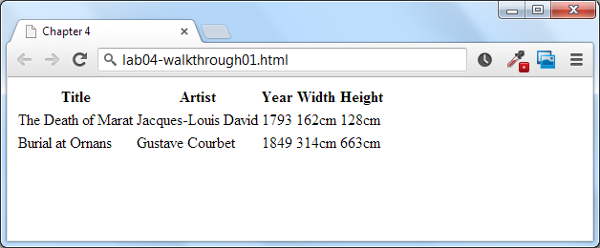

Figure 5.1 – Exercise 5.1 Complete

|  |
| --- |
| Exercise 5. — Complex Content in Tables |
| 1 | Open, examine, and test lab05-exercise02.html in browser. |
| 2 | Add the following content to the table.  <table>  <tr>  <th></th>  <th>Work</th>  <th>Year</th>  <th>Size</th>  </tr>  <tr>  <td><img src="images/art/05030.jpg" alt="The Death of Marat" /></td>  <td><em>The Death of Marat</em><br/>Jacques-Louis David</td>  <td>1793</td>  <td>Width: 162cm<br/>Height: 128cm</td>  </tr>  <tr>  <td><img src="images/art/10020.jpg" alt="Burial at Ornans" /></td>  <td><em>Burial at Ornans</em><br/>Gustave Courbet</td>  <td>1849</td>  <td>Width: 314cm<br/>Height: 663cm</td>  </tr>  <tr>  <td><img src="images/art/06020.jpg" alt="Betty de Rothschild" /></td>  <td><em>Betty de Rothschild</em><br/>Jean-Auguste Ingres</td>  <td>1848</td>  <td>Width: 142cm<br/>Height: 101cm</td>  </tr>  <tr>  <td><img src="images/art/13030.jpg" alt="Arrangement in Grey and Black" /></td>  <td><em>Arrangement in Grey and Black</em><br/>James Abbott Whistler</td>  <td>1871</td>  <td>Width: 144cm<br/>Height: 162cm</td>  </tr>  </table>  Here we are adding content to an existing table structure. Notice that some cells contain multiple HTML elements. |
| 3 | Test in browser. The result should look similar to that shown in Figure 5.2. |

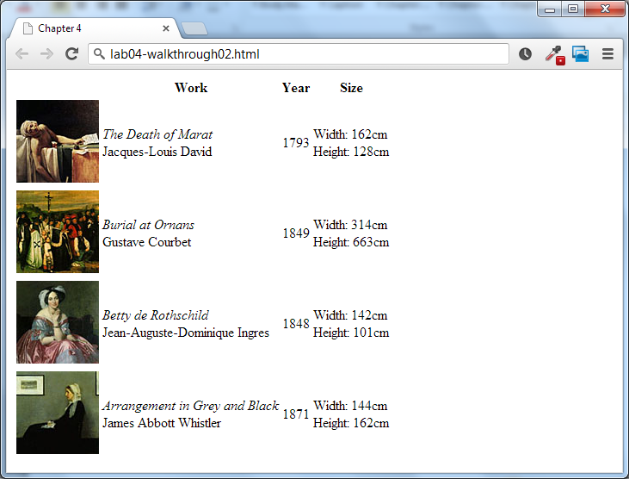

Figure 5.2 – Exercise 5.2 complete

|  |
| --- |
| Exercise 5. — Spanning Rows and Columns |
| 1 | Open, examine, and test lab05-exercise03.html in browser. |
| 2 | Add the following style to the <head> of the document and test.  <style>  td, th { border: solid 1pt black; }  </style>  This will make the structure of the table more obvious. |
| 3 | Add the following two tags to the beginning of the table and test in browser.  <tr>  <th>Artist</th>  <th colspan="4">Work Details</th>  </tr>  <tr>  <td rowspan="4">  <img src="images/art/5.jpg" alt="Jacques-Louis David" />  <br/><strong>Jacques-Louis David</strong>  </td>  </tr> |
| 4 | Add the following element at the beginning of the table.  <table>  <caption>Artist Inventory</caption>  <tr>  <th>Artist</th>  The caption is used to provide a title for the table, which improves accessibility. |
| 5 | Test in browser. The result should be similar to that shown in Figure 5.3. |

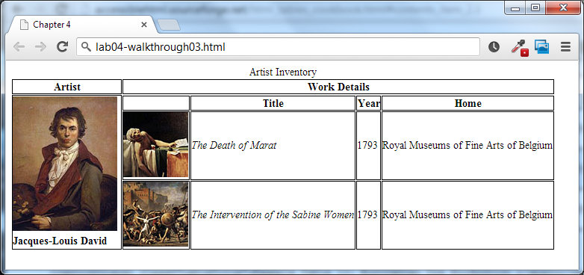

Figure 5.3 – Exercise 5.3 complete

|  |
| --- |
| Exercise 5. — Alternate Table Structure Elements |
| 1 | Open, examine, and test lab05-exercise04.html in browser.  Notice that the <td> element can be used in rows and columns. |
| 2 | Add the following attributes to the table headings.  <table>  <caption>Pricing Table</caption>  <tr>  <th></th>  <th scope="col">Free</th>  <th scope="col">Basic</th>  <th scope="col">Premium</th>  </tr>  <tr>  <th scope="row">Upload Space</th>  <td>50MB</td>  <td>200MB</td>  <td>Unlimited</td>  </tr>  <tr>  <th scope="row">Daily Uploads</th>  <td>1</td>  <td>10</td>  <td>Unlimited</td>  </tr>  <tr>  <th scope="row">Total Uploads</th>  <td>20</td>  <td>100</td>  <td>Unlimited</td>  </tr>  <tr>  <th scope="row">Social Sharing</th>  <td></td>  <td></td>  <td></td>  </tr>  <tr>  <th scope="row">Analytics</th>  <td></td>  <td></td>  <td></td>  </tr>  </table>  This improves the accessibility of the table. |
| 3 | Add the following around the first row.  <thead>  <tr>  <th></th>  <th scope="col">Free</th>  <th scope="col">Basic</th>  <th scope="col">Premium</th>  </tr>  </thead> |
| 4 | Test in browser. There is no special formatting for this element; instead we can apply special styling to it. |
| 5 | Add the following element around the other table rows.  <tbody>  <tr>  <th scope="row">Upload Space</th>  <td>50MB</td>  <td>200MB</td>  <td>Unlimited</td>  </tr>  <tr>  <th scope="row">Daily Uploads</th>  <td>1</td>  <td>10</td>  <td>Unlimited</td>  </tr>  <tr>  <th scope="row">Total Uploads</th>  <td>20</td>  <td>100</td>  <td>Unlimited</td>  </tr>  <tr>  <th scope="row">Social Sharing</th>  <td></td>  <td></td>  <td></td>  </tr>  <tr>  <th scope="row">Analytics</th>  <td></td>  <td></td>  <td></td>  </tr>  </tbody>  Like with the <thead> element, there is no preset-browser formatting associated with the <tbody> element. |
| 6 | Add the following element between the <thead> and <tbody> element.  <tfoot>  <tr>  <th scope="row">Price per year</th>  <td>Free</td>  <td>$ 9.99</td>  <td>$ 19.99</td>  </tr>  </tfoot> |
| 7 | Test in browser.  Notice the <tfoot> appears at the end of the table but should appear in the markup before the <tbody> element. |

## Styling Tables

|  |
| --- |
| Exercise 5. — Simple Table Styling |
| 1 | Open, examine, and test lab05-exercise05.html in browser. |
| 2 | Add the following style to the <style> element and test.  table {  border: solid 1pt black;  } |
| 3 | Change the style as follows and test.  table, td {  border: solid 1pt black;  } |
| 4 | Add the following and test.  td, table {  border: solid 1pt black;  border-collapse: collapse;  } |
| 5 | Add the following and test.  td, table {  border: solid 1pt black;  border-collapse: collapse;  padding: 0.5em;  } |
| 6 | Replace the above styles with the following and test.  table {  font-family: "Lucida Sans", Verdana, Arial, sans-serif;  font-size: 1em;  }  tbody {  background-color: #F1F1F1;  }  td, th {  padding: 0.5em;  }  thead, tfoot {  background-color: #CACACA;  } |
| 7 | Add the following and test.  caption {  font-size: 1.2em;  font-weight: bold;  background-color: #DCA806;  padding: 0.5em;  } |

|  |  |
| --- | --- |
| 8 | Add the following styles and test. The final result should look similar to Figure 5.4.  tbody tr:nth-child(odd) {  background-color: white;  }  This changes the background color of every other row within the <tbody> |

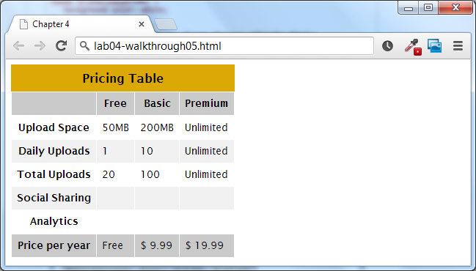

Figure 5.4 – Exercise 5.5 complete

|  |
| --- |
| Exercise 5. — CSS3 Table Styling |
| 1 | Open, examine, and test lab05-exercise06.html in browser. |
| 2 | Add the following style and test.  caption {  margin-left: -2000px;  }  While we want to keep the caption element for accessibility reasons, we don’t, in this case, want it to be visible. Shifting it to the left off screen does that. In Chapter Five, you will learn how to do this via CSS positioning. |

|  |  |
| --- | --- |
| 3 | Add the following to the bottom two rows of the markup.  <tr>  <th scope="row">Social Sharing</th>  <td></td>  <td><span class="check"></span></td>  <td><span class="check"></span></td>  </tr>  <tr>  <th scope="row">Analytics</th>  <td></td>  <td></td>  <td><span class="yes"></span></td>  </tr> |
| 4 | Add the following style and test.  tbody span.yes:before {  content: url(images/yes16.png);  }  The before or after pseudo-elements allow you to insert content before or after the content of an element. In this case we are adding an image into the select cells. |
| 5 | Add the following style and test.  tbody th {  text-align:right;  color: #1D1626;  background-color: #F2E0BD;  }  This will make the first column within the <tbody> element different from the other columns. |
| 6 | Add the following style and test.  thead th:empty {  background-color: white;  }  This uses the empty pseudo-element to select any empty <th> element within the <thead>. |
| 7 | Add the following style and test.  tfoot th {  background-color: white;  } |
| 8 | | Add the following style and test.  tfoot {  color: #C74223;  text-shadow:1px 1px 1px black;  font-weight: bold;  }  This changes every element within the <tfoot> element. |
| 9 | | Change the following style and test.  tfoot th {  background-color: white;  text-shadow: none;  }  This removes the text shadow from the first cell of the footer. |
| 10 | | Modify the following style and test. The result should look like that in Figure 5.5.  tfoot, thead th:nth-last-child(1) {  color: #C74223;  text-shadow:1px 1px 1px #000;  font-weight: bold;  }  This selects the last cell in the <thead> so that it has the same styling as the footer elements. |

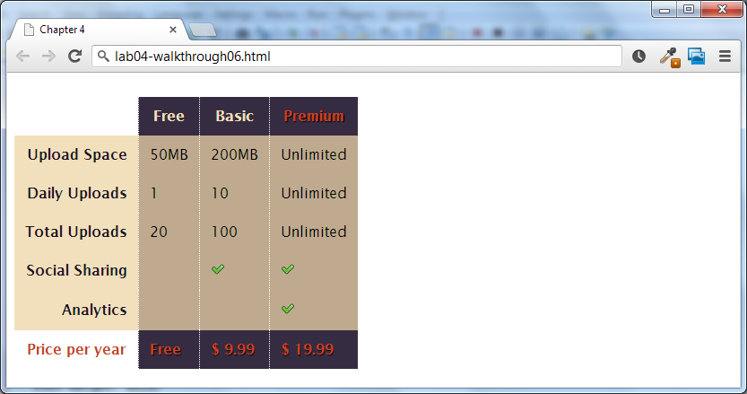

Figure 5.5 – Exercise 5.6 complete

## Creating Forms

Forms provide the user with an alternative way to interact with a web server. Up to now, clicking hyperlinks was the only mechanism available to the user for communicating with the server. Forms provide a much richer mechanism. Using a form, the user can enter text, choose items from lists, and click buttons. Typically programs running on the server will take the input from HTML forms and do something with it, such as save it in a database, interact with an external web service, or customize subsequent HTML based on that input.

A form is constructed in HTML in the same manner as tables or lists: that is, using special HTML elements.

|  |
| --- |
| Exercise 5. — Creating a Form |
| 1 | Open lab05-exercise07.html in text editor. |
| 2 | Add the following to the <body> of the document.  <form method="get" action="">  <fieldset>  <legend>Details</legend>  <p>  <label>Title: </label>  <input type="text" name="title" />  </p>  <p>  <label>Country: </label>  <select name="where">  <option>Choose a country</option>  <option>Canada</option>  <option>Finland</option>  <option>United States</option>  </select>  </p>  <input type="submit" />  </fieldset>  </form> |
| 3 | Test in browser. |

|  |  |
| --- | --- |
| Exercise 5. — Testing a Form | |
| 1 | Open lab05-exercise08.html in text editor. | |
| 2 | Modify the <form> element as follows then test.  <form method="get" action="http://www.randyconnolly.com/tests/process.php">  This sample PHP script on the book’s web site simply echoes back any form data in the request. | |
| 3 | Modify the <form> element as follows then test.  <form method="post"  action="http://www.randyconnolly.com/tests/process.php"> | |

## Form Controls

|  |  |
| --- | --- |
| Exercise 5. — Text Controls | |
| 1 | Open and examine lab05-exercise09.html. | |
| 2 | Modify the form as follows and test.  <p>  <label>Title: </label><br/>  <input type="text" name="title" />  </p>  <p>  <label>Password: </label><br/>  <input type="password" name="pass" size="8"/>  </p>  <p>  <label>Email: </label><br/>  <input type="email" name="email" size="45"/>  </p>  <p>  <label>Website: </label><br/>  <input type="url" name="website" size="45"/>  </p>  <p>  <label>Description: </label><br/>  <textarea placeholder="enter a description" rows="5"  cols="45"></textarea>  </p> | |

|  |  |
| --- | --- |
| Exercise 5. — Choice Controls | |
| 1 | Open and examine lab05-exercise10.html. | |
| 2 | Modify the form as follows and test (be sure to submit form).  <p>  <label>Countries: </label><br/>  <select name="country">  <option>Australia</option>  <option>Canada</option>  <option>France</option>  <option>Sweden</option>  <option>Thailand</option>  <option>United States</option>  </select>  </p>  <p>  <label>Continent: </label><br/>  <select size="4" name="continent">  <option value="NA">North America</option>  <option value="EU">Europe</option>  <option value="AS">Asia</option>  <option value="SA">South America</option>  </select>  </p>  <p>  <label>City: </label><br/>  <select name="city">  <optgroup label="North America">  <option>Calgary</option>  <option>Los Angeles</option>  </optgroup>  <optgroup label="Europe">  <option>London</option>  <option>Paris</option>  <option>Prague</option>  </optgroup>  </select>  </p>  <p>  <label>Gender of Traveler: </label><br/>  <input type="radio" name="gender" value="1">Female<br/>  <input type="radio" name="gender" value="2">Male<br/>  </p>  <p>  <label>How did you hear about the site: </label><br/>  <input type="checkbox" name="hear" value="email">Email<br/>  <input type="checkbox" name="hear" value="friend">Friend<br/>  <input type="checkbox" name="hear" value="website">Website  </p> | |

|  |  |
| --- | --- |
| Exercise 5. — Button Controls | |
| 1 | Open and examine lab05-exercise11.html. | |
| 2 | Modify the form as follows and test.  <p>  <input type="button" value="Click Me" />  <input type="image" src="images/yes16.png" />  <input type="image" src="images/no16.png" />  </p>  <p>  <button>  <a href="#">  <img src="images/yes16.png" alt=""/>  Yes  </a>  </button>  <button>  <img src="images/no16.png" alt=""/>  No  </button>  </p>  <p>  <input type="submit" />  <input type="reset" />  </p> | |

|  |  |
| --- | --- |
| Exercise 5. — Specialized Controls | |
| 1 | Open and examine lab05-exercise12.html. | |
| 2 | Modify the form as follows and test (be sure to submit form).  <p>  <label>Rate this photo: </label><br/>  <input type="number" min="1" max="5" name="rate" />  </p>  <p>  Happiness Rating: Grumpy  <input type="range" min="0" max="10" step="1" name="happiness" />  Ecstatic  </p>  <p>  <label>Companion Color: </label><br/>  <input type="color" name="back" />  </p>  Note: not every browser supports all of these controls. | |

|  |  |
| --- | --- |
| Exercise 5. — Date and Time Controls | |
| 1 | Open and examine lab05-exercise13.html. | |
| 2 | Modify the form as follows and test (be sure to submit form).  <p>  <label>Date of photo: </label><br/>  <input type="date" name="photodate" />  </p>  <p>  <label>Time of photo: </label><br/>  <input type="time" name="phototime" />  </p>  <p>  <label>Date and time of photo: </label><br/>  <input type="datetime" name="photodatetime" />  </p>  <p>  <label>Week of photo: </label><br/>  <input type="week" name="photoweek" />  </p>  Note: not every browser supports all of these controls. | |

## Complete your Lab Report

Open *lab 05 report.doc* and answer the questions based on what you learned in this lab exercise. Save your lab report as ***lab05_yourname*** and submit your report via ***dropbox*** on ***elearning*** under ***lab 05 Report Submission* before Sunday 11:59PM.**